📊
Sales Data Analysis Report
Interactive Sales Dashboard Project
Analysis period: January 1 – April 9, 2024
Prepared July 2026

Table of Contents

Table of Contents.............................................................................................................. 2
1. Overview...................................................................................................................... 3
2. Methodology................................................................................................................ 3
3. Key Findings.................................................................................................................. 3
3.1 Sales Trend.............................................................................................................. 3
3.2 Product Performance............................................................................................... 3
3.3 Regional Performance.............................................................................................. 5
3.4 Customer Segmentation........................................................................................... 6
3.5 Correlations............................................................................................................. 7
4. Recommendations........................................................................................................ 7
5. Limitations.................................................................................................................... 8
6. Reproducibility.............................................................................................................. 8

1. Overview
This report summarizes an exploratory analysis of sales_data.csv, a 100-record retail transaction log spanning January 1 – April 9, 2024 across 5 electronics products and 4 U.S. regions. Total revenue across the period was $12,365,048.

2. Methodology
- Data validation — confirmed no missing values across all 100 rows and 7 columns; verified Total_Sales = Quantity × Price for every record.
- Feature engineering — added a 7-day rolling average of daily sales to smooth short-term noise, and a Value_Tier field (Bronze/Silver/Gold/Platinum) from quartiles of Total_Sales, used as a proxy for customer segmentation since each Customer_ID places only one order in this dataset.
- Statistical testing — a one-way ANOVA was run on unit price across the five product categories to test whether differences in mean price are statistically significant.
- Visualization — seven Seaborn statistical charts and four interactive Plotly views were produced, sharing one coordinated color palette.

3. Key Findings

3.1 Sales Trend
Daily sales are volatile (single orders ranging from ~$6.5K to ~$374K), but the 7-day rolling average shows an early spike in the first week of January, a relative lull through February and early March, and a recovery into late March / early April.
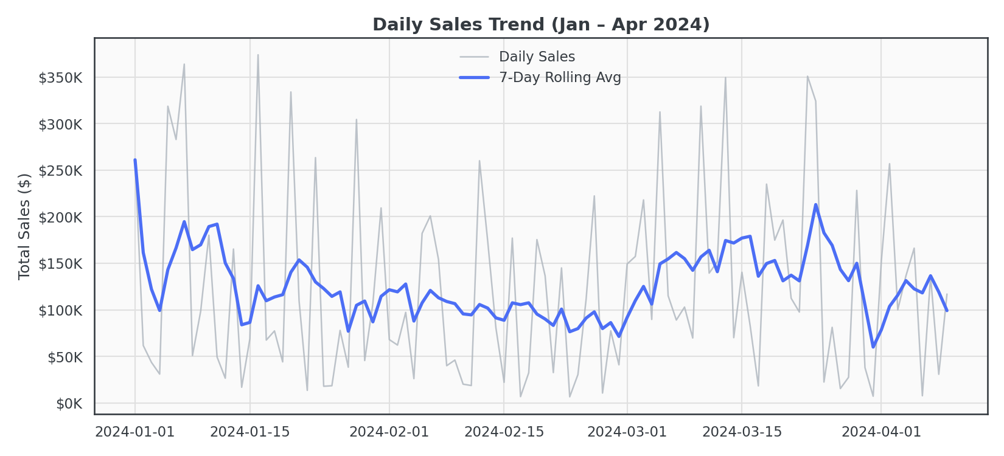
Figure 1. Daily sales trend with 7-day rolling average.

3.2 Product Performance
Total revenue by product:
Product | Total Sales | Avg. Unit Price
Laptop | $3,889,210 | $27,651
Tablet | $2,884,340 | $24,177
Phone | $2,859,394 | $27,379
Headphones | $1,384,033 | $28,692
Monitor | $1,348,071 | $20,710

Laptops are the single largest revenue driver, roughly 35% ahead of the second-place Tablet/Phone tier. Headphones and Monitors lag well behind — likely a combination of lower order volume and (for Monitors specifically) the lowest average unit price of the five categories.
A one-way ANOVA on unit price across products returned F = 0.92, p = 0.456, meaning there is no statistically significant difference in average unit price between product categories at the 0.05 level — the revenue gap between Laptops and Monitors is driven more by order volume/mix than by price-point differences.
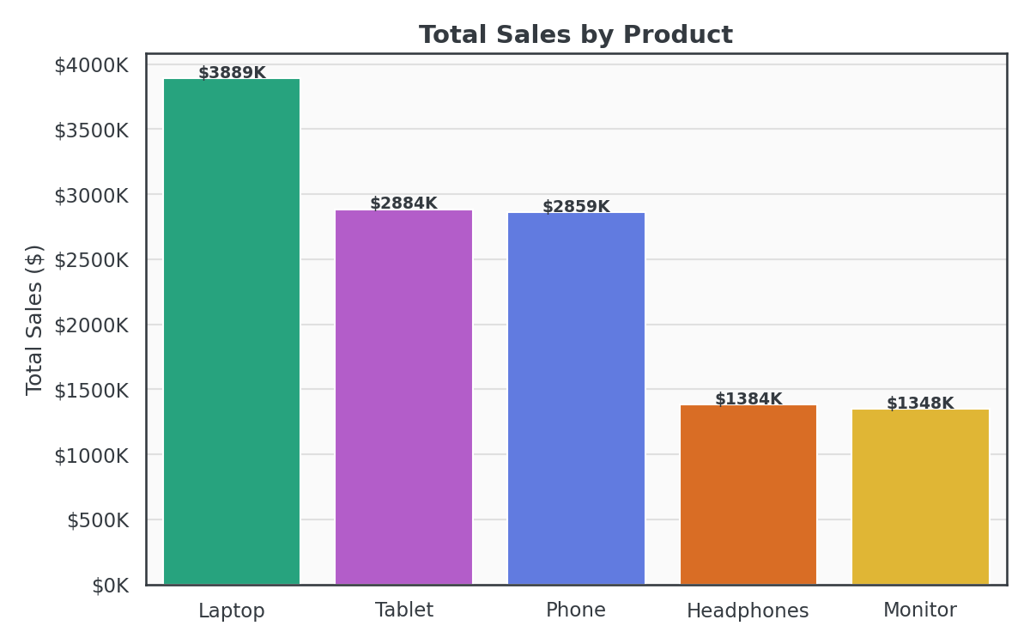
Figure 2. Total sales by product.
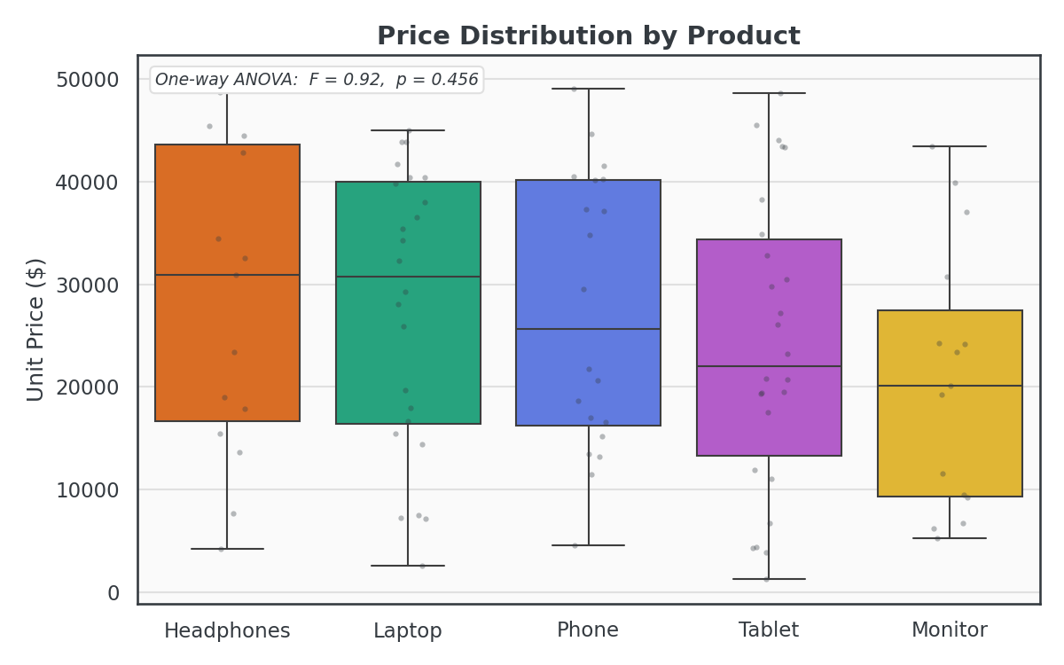
Figure 3. Price distribution by product, with one-way ANOVA annotation.

3.3 Regional Performance
Total revenue by region:
Region | Total Sales
North | $3,983,635
South | $3,737,852
East | $2,519,639
West | $2,123,922

North and South together account for roughly 63% of total revenue, nearly double the combined East + West total. Order-quantity distributions (violin plot) are broadly similar in shape across all four regions, with North showing a slightly higher median quantity per order.
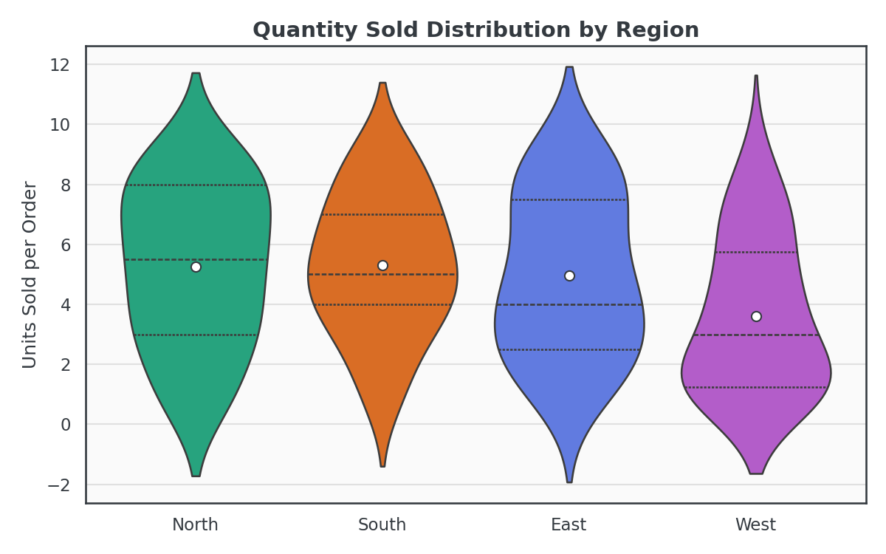
Figure 4. Quantity sold distribution by region.

3.4 Customer Segmentation
Since every Customer_ID in this dataset corresponds to exactly one order, segmentation was performed on order value rather than purchase frequency. Splitting all orders into value quartiles (Bronze → Platinum) and cross-tabulating by region shows that high-value ("Platinum") orders are not concentrated in any single region — they are fairly evenly distributed, suggesting big-ticket purchases aren't a purely regional phenomenon in this sample.
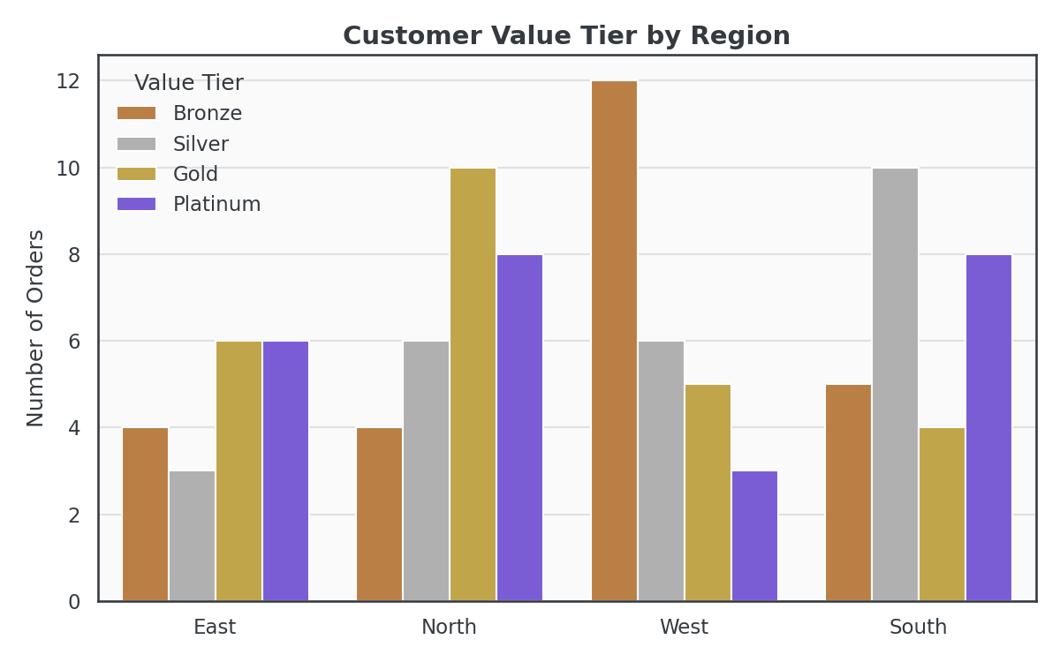
Figure 5. Customer value-tier segmentation by region.

3.5 Correlations
- Quantity ↔ Total_Sales: r ≈ 0.69 (moderate-strong positive)
- Price ↔ Total_Sales: r ≈ 0.65 (moderate-strong positive)
- Quantity ↔ Price: r ≈ 0.01 (effectively no relationship)

Both quantity and price contribute comparably to total order value, and they are independent of one another — customers are not systematically buying more units of cheaper items or vice versa.
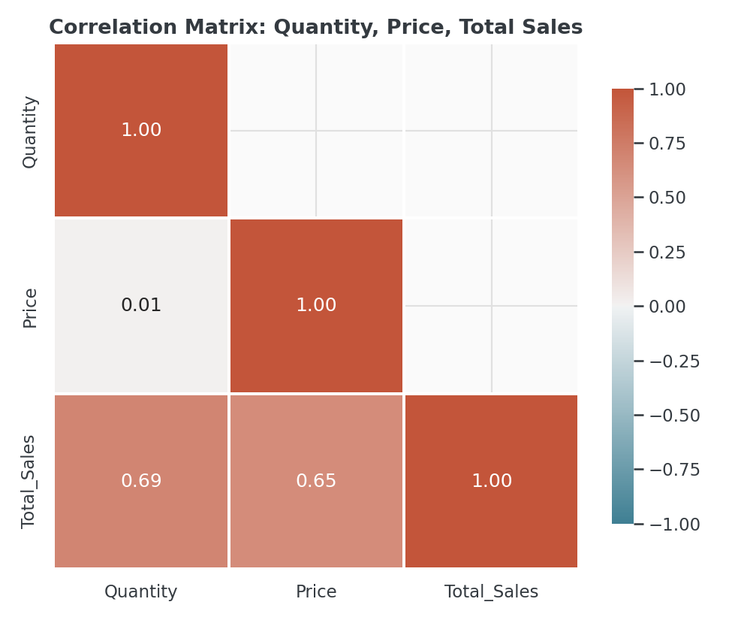
Figure 6. Correlation matrix: Quantity, Price, Total Sales.

4. Recommendations
- Double down on Laptops, the clear revenue leader, e.g. bundling accessories (Headphones, Monitors) with laptop purchases to lift the weaker categories.
- Investigate the East/West revenue gap — since unit prices don't differ significantly by product, the gap versus North/South is more likely a volume or market-size effect worth digging into with more granular data (e.g., number of unique buyers, marketing spend by region).
- Track true repeat-purchase behavior — this dataset only contains one order per customer, so a genuine RFM (Recency/Frequency/Monetary) segmentation isn't possible yet. Capturing multiple orders per customer in future data collection would substantially improve the segmentation analysis.

5. Limitations
- Sample size is small (100 orders over ~100 days), so findings should be treated as directional rather than definitive.
- No customer demographic or marketing-channel data was available, limiting the depth of segmentation analysis.
- Each customer appears exactly once, so frequency- and loyalty-based segmentation could not be performed.

6. Reproducibility
All figures in this report were generated by dashboard.ipynb from the raw sales_data.csv file — see README.md for setup and run instructions. Static chart images are in the visualizations/ folder, and the interactive dashboard is interactive_dashboard.html.

